

HOSPITAL MANAGEMENT SYSTEM

MINOR PROJECT - I

Submitted in Partial Fulfilment of the Requirements for the Award of the Degree of
MASTER OF COMPUTER APPLICATIONS
(M.C.A.)

BY
ROOPANSH SETHI
(35911604422)
MCA – 1st SEMESTER



BHARATI VIDYAPEETH’S INSTITUTE OF COMPUTER APPLICATIONS AND MANAGEMENT (BVICAM)
(GURU GOBIND SINGH INDRAPRASTHA UNIVERSITY)
NEW DELHI
January, 2023
CANDIDATE’S DECLARATION
I hereby declare that the work which is being presented in this project work entitled “Hospital Management System” in partial fulfilment of the requirements for the award of the degree of Master in Computer Applications at Bharati Vidyapeeth’s Institute of Computer Applications and Management (BVICAM), New Delhi is an authentic record of my own work carried out during the period January 2021 to April 2022 under the supervision and guidance of Faculty Name Ms. Parul Arora (Associate Professor, BVICAM).
I have not submitted the matter embodied in this project work anywhere for the award of any degree or diploma.

ROOPANSH SETHI
Enroll. No. 35911604422

ACKNOWLEDGEMENT
It is my proud privilege to express my profound gratitude to the entire management of Bharati Vidyapeeth’s Institute of Computer Applications and Management and teachers of the institute for providing me with the opportunity to avail the excellent facilities and infrastructure. The knowledge and values inculcated have proved to be of immense help at the very start of my career. Special thanks to Hon’ble Founder, Bharati Vidyapeeth, Pune for having provided us an excellent infrastructure at BVICAM.

I am grateful to Dr.Ritika Wason (Project Guide, BVICAM, New Delhi) for his astute guidance, constant encouragement and sincere support for this project work.

I feel pride and privileged in expressing my deep sense of gratitude to all those who have helped me in presenting this assignment. I would be failing in my endeavour if I do not place my acknowledgement.

??? ??? ??? ???

ROOPANSH SETHI
Enroll. No. 35911604422
ABSTRACT
In This Minor Project, We Have Developed A Ide Based Application For Managing Patient Record
This Application Is Developed Using Netbeans Ide With Java Programming. MySql Database Management Syatem (Dbms) Is Used To Manage The Database Of Application The Development Of Application Is Carried Out By Following Waterfall Model, The Application Provide Robust And Reliable Services There Are Mainly Three Modules Of The System Is Login , Reception, Diagnostic That Is Used For Managing The Records Of The Patient . All The Modules Are Tested After Successful Testing The System Is Ready With The Friendly User Interface .

TABLE OF CONTENTS
 |  | Page No.
CHAPTER 1: INTRODUCTION
1.1 | INTRODUCTION ABOUT PROJECT | 8
1.2 | NEED OF COMPUTERIZATION OF SYSTEM/ PROBLEM IN EXISTING SYSTEM | 9
1.3 | PROPOSED SOFTWARE (WHAT WOULD S/W ACCOUMPLISH) | 9
1.4 | IMPORTSANCE OF THE WORK/ PROJECT | 10
CHAPTER 2: PROJECT DESCRIPTION
2.1 | Analysis Methodology | 12
2.2 | Feasibility Study | 13
2.3 | Choice of Platform
 | 2.3.1 Software Used | 14
 | 2.3.2 Hardware Used | 14
2.4 | Testing Methodology | 14
2.5 | Testing Methodology applied (why) | 15
2.6 | Test Case | 16
2.7 | Test Data | 17
2.8 | Rework/Retest | 17
2.9 | Analysis (Planned Vs Achieved) | 17
2.10 | Hardware & Software Requirement | 17
 | 2.10.1 Hardware Requirement  2.10.2 Software Requirement | 17
CHAPTER 3: FUNCTIONALITIES
3.1 | Process Model Used | 19
3.2 | Use Case Diagram | 20
3.3 | Data Base Design (ERD) | 21
3.4 | Functional Design (DFD) | 22
3.5 | Interface Design (Screen Shots of Form) | 24
3.6 | Output Design (Screen Shots of Report | 27
CHAPTER 4: CONCLUSION AND FUTURE SCOPE
4.1 | CONCLUSION | 31
4.2 | LIMITATIONS OF EXISTING SYSTEM | 31
4.3 | FUTURE SCOPE | 31
4.2 | BIBLOGRAPHY/REFERENCES | 32

CHAPTER 1: INTRODUCTION

1.1 Introduction about Project
1.2 Need of Computerization of System/ Problem in existing system
1.3 Proposed Software (What would S/W accomplish?)
1.4 Importance of the Work/project

1.1 Introduction about Project
The Covid-19 pandemic has created a multitude of acute challenges for health care delivery organizations and at this point, every hospital needs a robust hospital management software in which a person can rely upon. The Hospital Management System developed by us will not only store the data of patients and healthcare providers but also provide a user friendly GUI and easy search options so that they can access their data rapidly which will help the hospital to function in a finer manner.
Our hospital system software covers the services that simplify the work of healthcare professionals as well as their interactions with patients.
Therefore, the main features of our software are:
- In earlier times, records were maintained in bulky notebooks, which were difficult to maintain and edit. To overcome a problem our software will store all data on computer systems, which will reduce the wastage of natural resources like pen, and paper there will be less errors.
- Records at the backend are getting stored in the form of tables, which are easy to interpret.
- With the help of SQL constraints, there is accuracy and reliability of the data in the database.
- It helps the user to add, edit, delete and searching the patient’s records at any time in few seconds so that user can find the information of any patient.
- It also helps the user to store data efficiently and effectively.
- Each patient is given a unique id and there will be no loss of data as it is maintained in the computer system.

1.2 Need of computerization of system/ Problem in existing system
Problem in Existing System
- It was time consuming to retrieve patient’s data
- Adding multiple records of different patients at the same time was impossible.
- The data given by patients was not structured which led to loss of important information.
Need of Computerization of System
Computerization system is necessarily required to solve the problem occurred by existing system. Computerization system is required so that it is possible to complete the process within a short period with least manual errors.
- To check in the redundancies timely
- Speedy transactions

1.3 Proposed software (what would s/w accomplish?)
- The software can add, edit, delete, view and the search data of patients quickly.
- To manage reception and diagnostic system separately which creates less ambiguity.
- More storage capacity
- Search facility

1.4 Importance of the Work/project
The project has been developed with utmost correctness. This system is prepared with the help of knowledgeable computer professionals. Chances of errors are low to none. Moreover, it satisfies all the user needs.

Further, the management of records of each department users becomes very easy and access of the records has become very easy by using Delhi Central Hospital (Hospital Management System).

CHAPTER 2: PROJECT DESCRIPTION
2.1 Analysis Methodology
2.2 Feasibility Study
2.3 Choice of Platforms
2.3.1 Software Used
2.3.2 Hardware Used
2.3 Testing Methodology
2.4 Testing Methodology applied (why)
2.5 Test Case
2.6 Test Data
2.7 Analysis (Planned Vs Achieved)
2.8 Hardware & Software Requirement
2.8.1 Hardware Requirement
2.8.2 Software Requirement

2.1 Analysis Methodology
Requirement gathering is the process of listing the requirements from the various stakeholders that will be used as the basis for the requirements definition.
Requirement gathering is essential for almost every project. The process of reviewing a business‘s processes to determine the business needs and functional requirements that a system must meet explanation of requirement gathering.
There are many types of requirement gathering techniques. Some of them:
- One on one Interview: In this type of interview, we gathered information from the hospital members in one on one basis who will be operating the software, which will help us in better understanding of the requirements.

- Questionnaire: The questionnaire had some questions regarding the hospital management and what things can be introduced for better functionality so that we can analyze all the requirements of the hospital and its different department.

- Observation: We have observed that previous system was very time consuming as all the work is done manually as they have not been introduced to a better way of working. All the work is done manually.

- Brainstorming: Brainstorming is used in requirement gathering to have as many ideas as possible from group of people. In this manner, we are getting a bunch of questions or ideas, which can be combined, for better functionality of software.

2.2 Feasibility Study
Feasibility study is a study to evaluate the feasibility of purposed system. This study is focused towards the managing the records of hospital’s department. This study analyses whether the software product is can be practically materialized in terms of implementation, contribution of project to the Hospital, cost constraint and as per values and objectives of the hospital.
There are some types of feasibility study:
- Economic Feasibility: With the help of Hospital Management System, the hospital saves a lot of money and natural resources, which is used in present to manage their records as well as future too.
- Technical Feasibility: With the help of Hospital Management System Software, the hospital is satisfying the users with their fulfilments of the requirements and information they asked for.
- Operational Feasibility: With the help, Hospital Management System software the hospital check and focus on the level, which the proposed system stands with the existing environment.

2.3 Choice of Platforms

2.3.1 Software Used
Operating System (OS) : Windows 10
Front End : NetBeans IDE 8.2
Back end : MySQL

2.3.2 Hardware Used
Processor : Intel(R) Core(TM) i5-3320m CPU @ 2.60GHz
System Bus : 64-bit OS
RAM : 8.00 GB
HDD : one TB

2.4 Testing Methodology
Testing is a process of executing a program with the significance of finding an error. A good test is one that has high probability of finding the yet unfound error. Testing should regularly uncover different classes of errors in a minimum amount of time with a minimum amount of efforts. A software composition that includes a software requirement specification, a design specification and source code.

Unit testing
The following units we have tested in the unit testing:
- List of members: In this unit all, the function is working properly and the output is as expected.
- Facility File: In this unit all, the functions are working properly and output as desired.
- Statement of marks: In this unit all the functions and components of the unit is working properly and output is as desired.

Integration testing
The software’s units are working well and integrated.

Validation testing
The software is completely assembled as a package, and interfacing errors have been uncovered and corrected.

Security testing
The security is a lacking area in this software, which will be a future work on this software.

2.5 Testing Methodology applied (why)
This is performed to ensure the functional, performance and reliability need placed on crucial design items. Assemblages are tested using black box testing with suitable test cases to duplicate success and error cases. Use of shared data and inter process communication is being tested on individual subsystem. Test cases are produced in order to check whether all the modules included in the assemblage is communicating correctly with each other it is done after unit testing. Building Block ideology is followed here in which assemblages are treated and bases that are verified as well as validated which provide further support to the testing of various other assemblages
Software testing life cycle is an integral part of SDLC, .the overall aspect of STLC phase deals with testing & rectifying any error code generating within the program under various test conditions The circular-dependencies for software integration testing are: scheduled for integration testing, strategy and selection of the tools used for integration, lining the cyclamate complication of the software and software structure, reusability of modules and life cycle.

2.6 Test Case
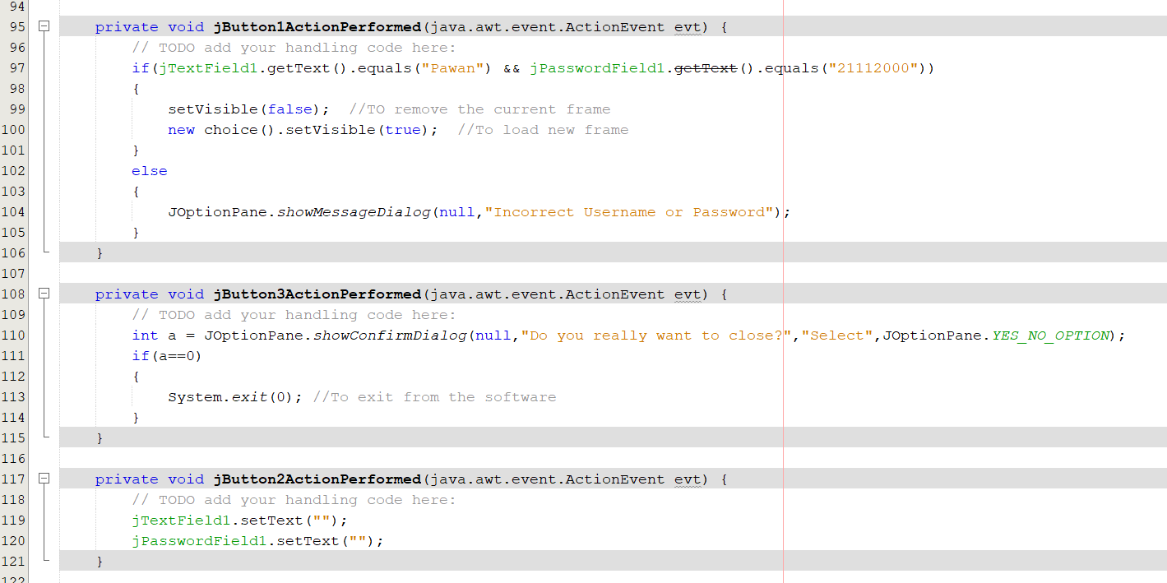
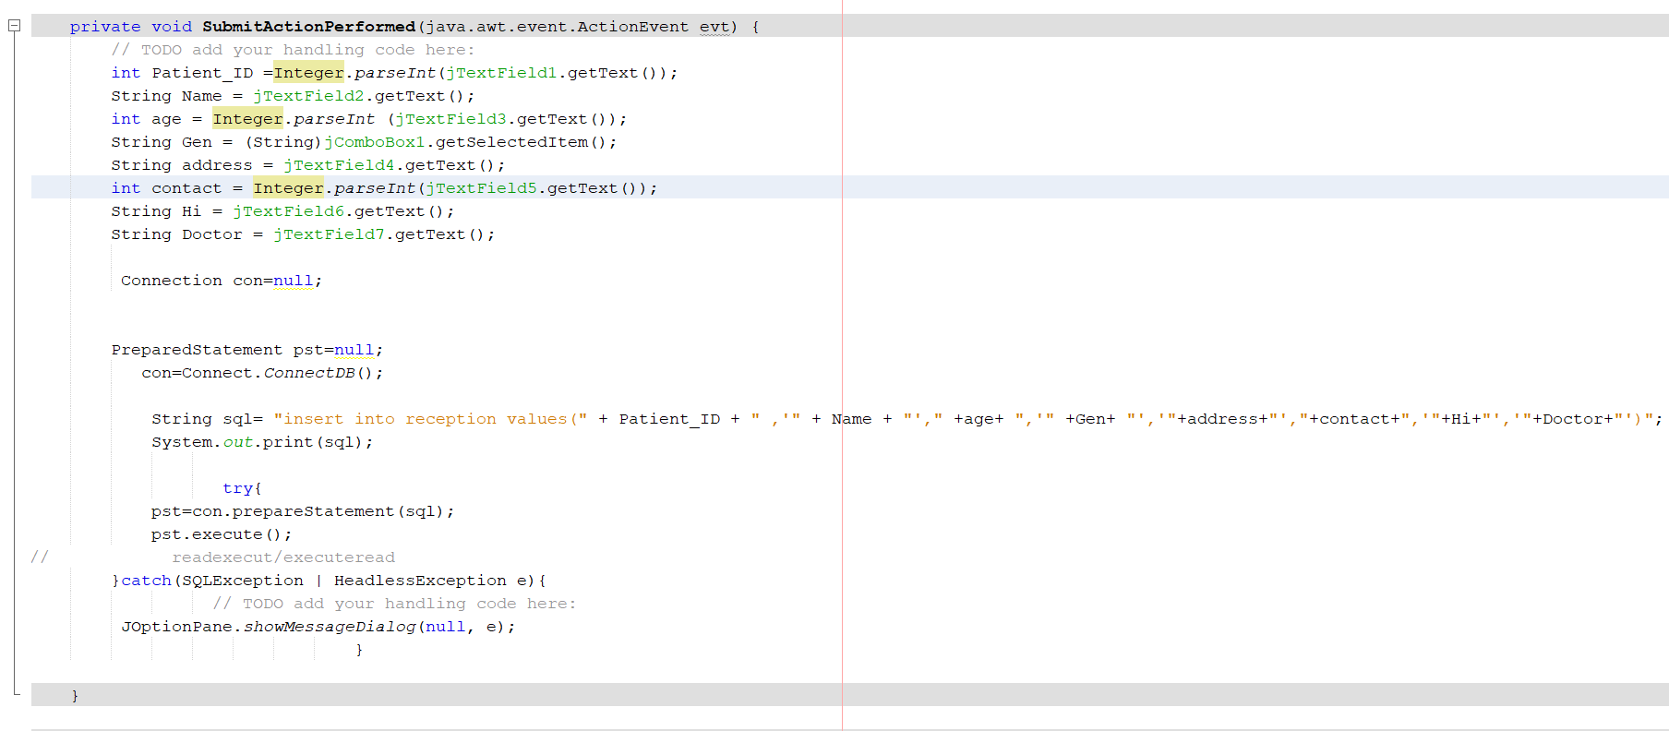

2.7 Test Data
This phase of system development life cycle refines hardware and software specification, establishes programming plans, trains users and implements extensive testing procedures, to evaluate design and operating specification and/or provide basis for further modifications.

2.8 Analysis (Planned Vs Achieved)
GAP Analysis is the process of comparing actual performance with the expected performance to decide whether it is meeting expectations of the employees or not.
GAP Analysis also looks at the progress of the current project and plans about the future of the organization.

2.9 Rework / Retest
Rework is a necessary process because if the errors are occurring, it is necessary to handle it. If there is any error, it is important to rectify it. After rework, it is necessary to do the testing again so that there is no chance of errors again.
In software or projects, Rework can avoid it from errors, omissions, failures, bugs, etc. However, rework occurs when there are errors in the software, project after the testing is done, or incorrect implementation is done.

2.10 Hardware & Software Requirement

4.6.1 Hardware Requirement
Operating System (OS) : Windows 7 or above
RAM : 4 GB
HDD : 500GB

4.6.2 Software Requirement
Operating System (OS) : Windows 7 or above
Front end : Java Development Kit
Back end : MySQL
IDE : NetBeans 8.2

CHAPTER 3: FUNCTIONALITIES

3.1 Use Case Diagram
3.2 Database Design (ERD/Data Dictionary/Table Design)
3.3 Functional Design (DFD)
3.4 Interface Design (Screen shots of forms)
3.5 Output Design (Screen Shots of Report)

3.1 Process model used
We have used Waterfall Model. It is classical model of software engineering. It is one of the oldest model, which is mostly used by much organization for their projects in order to reach their desired goal.

Waterfall model design-
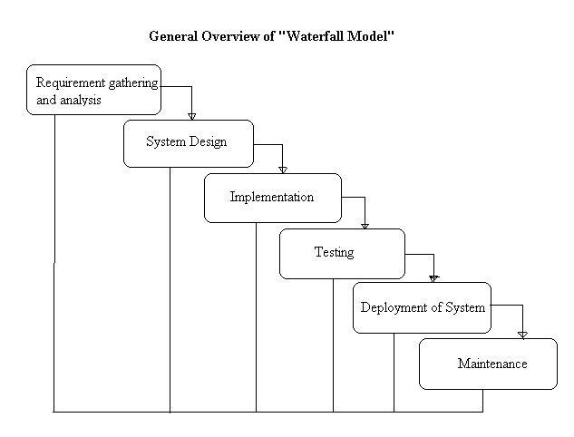
This model has six phases, which is shown in above image. In Requirement gathering and analysis we collect the information from the client that what he wants to perform the certain task by the software. After this step, we have to design the system as per the information. After the designing, we have to implement the design in coding. After coding, we perform testing, create the test cases, and test the code to find that software is working properly or not so that we can, make changes in code if there is any error or we did not get the expected output. After this step, we have to deployment of system for the user so that he can be able use the software. After previous steps, we have to just maintain and update the software as per the requirement.
Reason for using this model
Waterfall model is used for simple projects that does not require much of user intervention during its development. The time allotted was also limited and we initially planned our modules so waterfall is suitable for such cases where one phase being developed left untouched for next phases. Hence, I used waterfall model.

3.2 Use Case Diagram

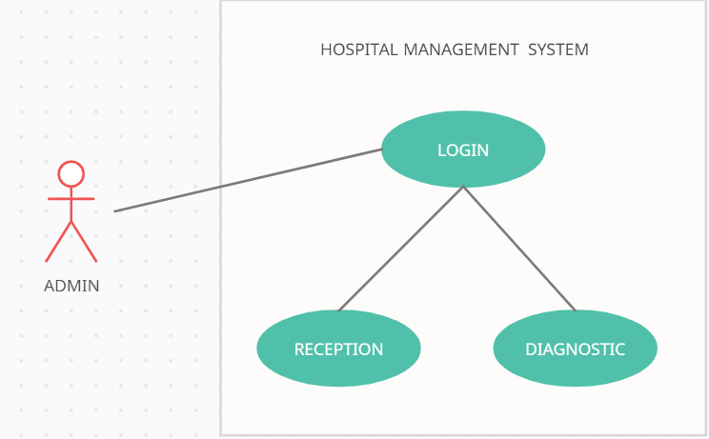

3.3 Database Design (ERD)
ENTITY RELATIONSHIP DIAGRAM

Test Name
Prescribed Doctor
LOGIN
ISA
Email Address
Contact No
Gender
Age
Name
Patient ID
Name
Age
Gender
Address
Contact No
Health Issue
RECEPTION
DIAGNOSTIC

3.4 Functional Design (DFD)
0-Level DFD
Diagnosis
Module
Reception
Module

Hospital
Management
System

Database

1-level DFD

RECEPTION
LOGIN
ID
& PASSWORD
DIAGNOSTIC
DATABASE 1
DATABASE 2

3.5 Interface Design

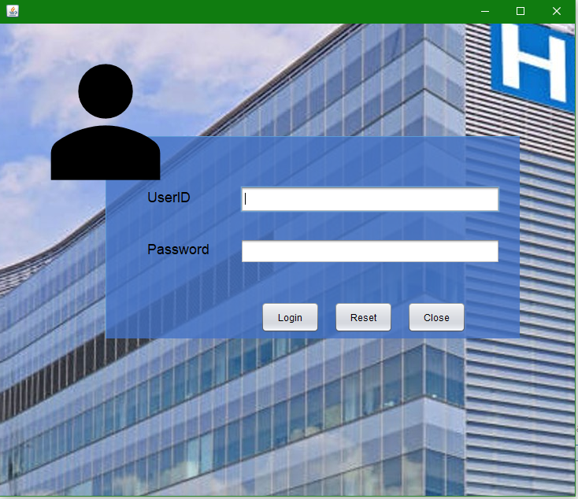

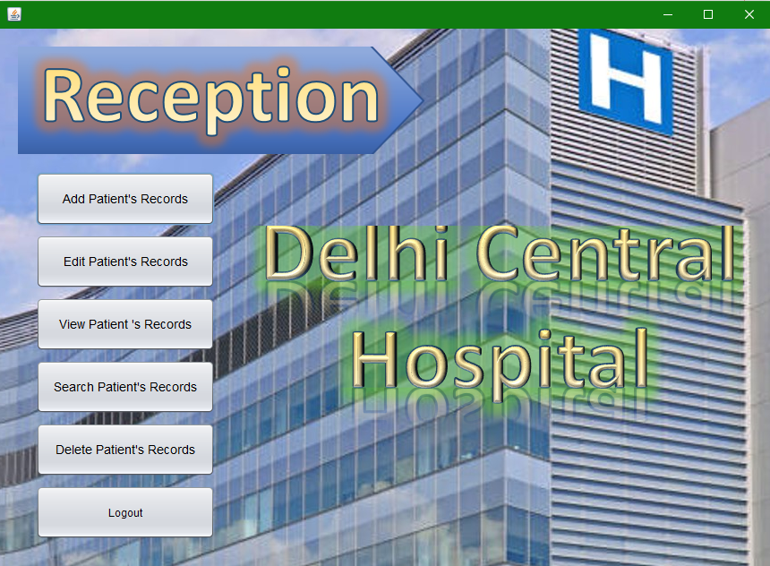
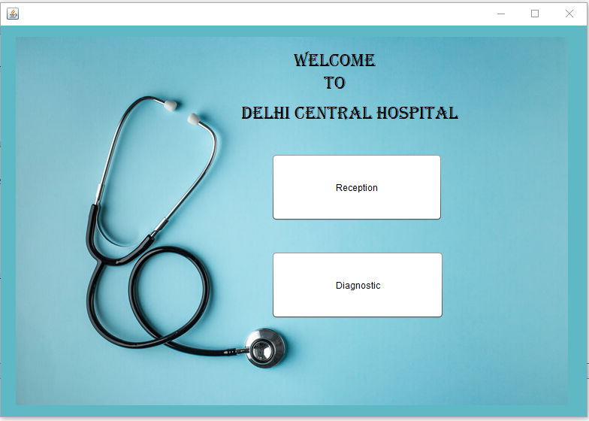
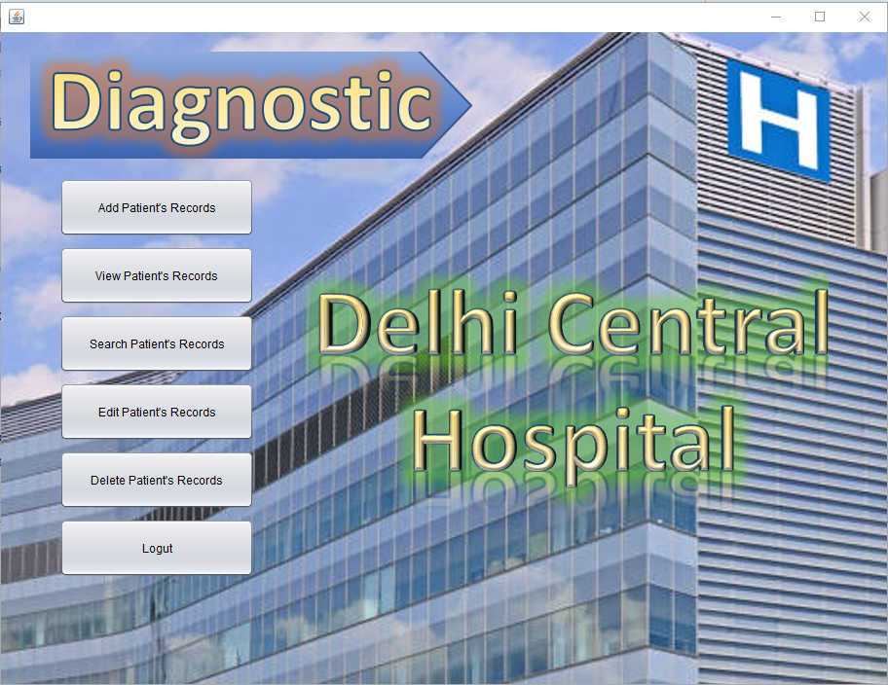

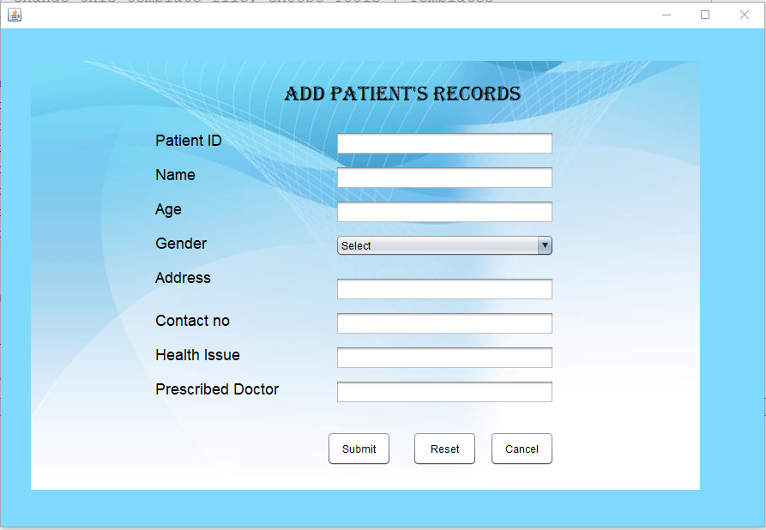
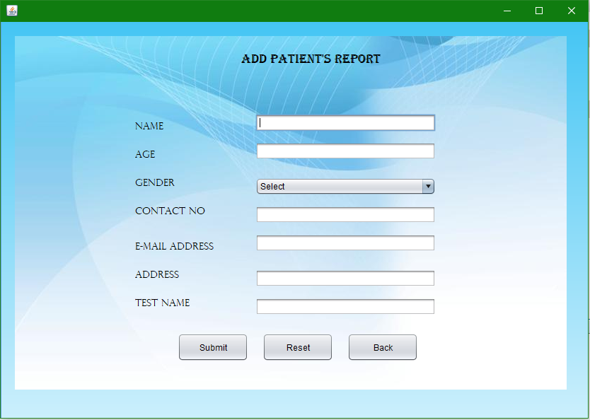
3.6 Output Design

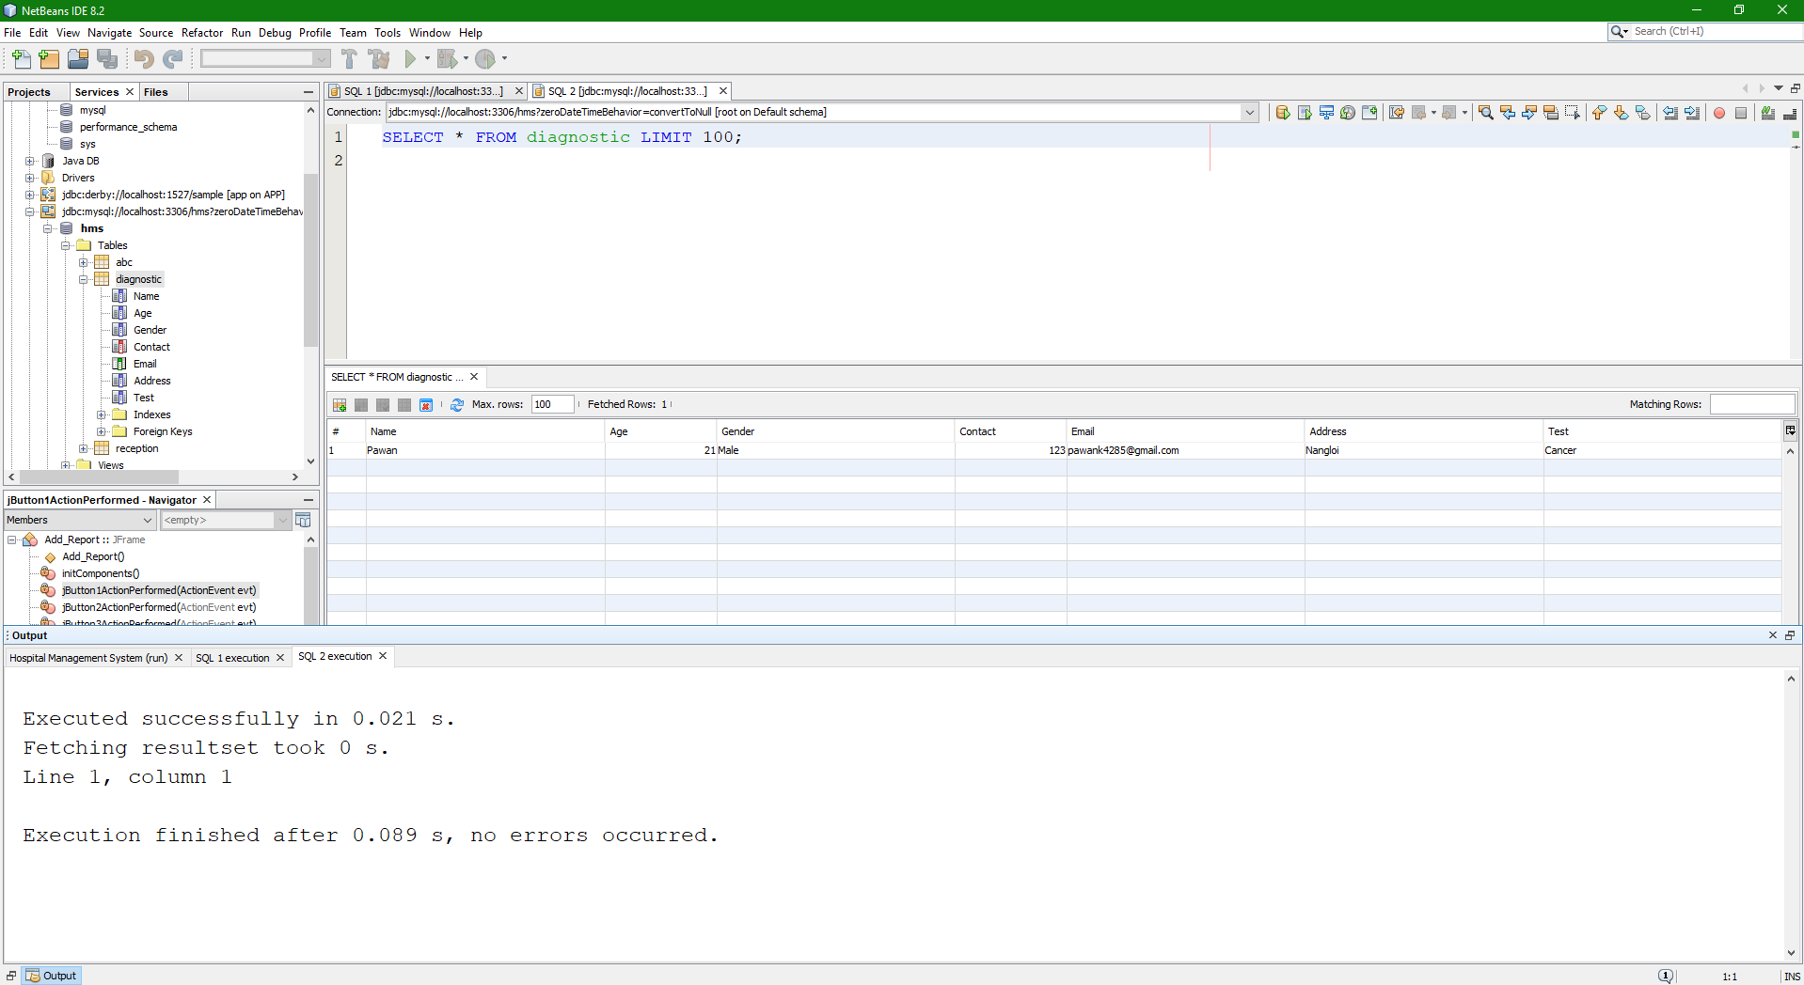
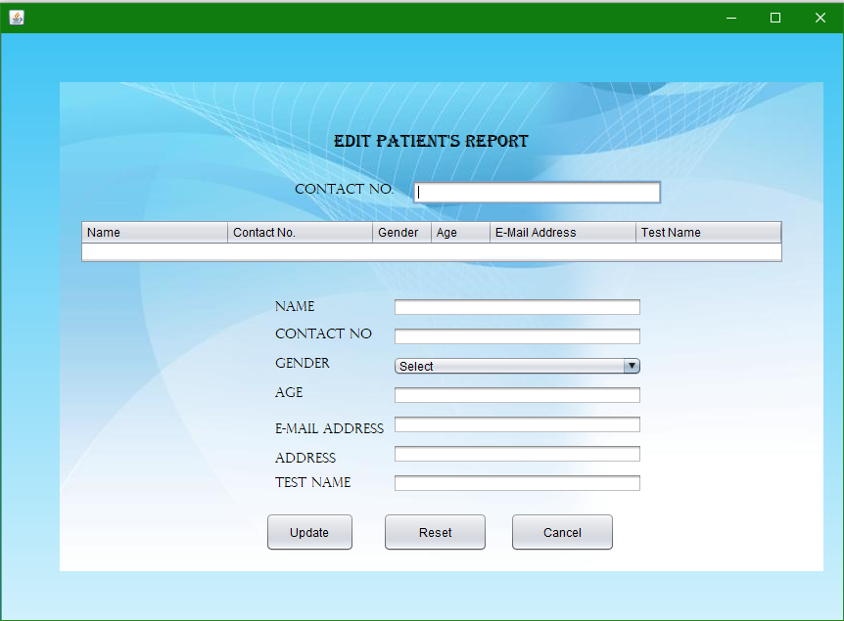

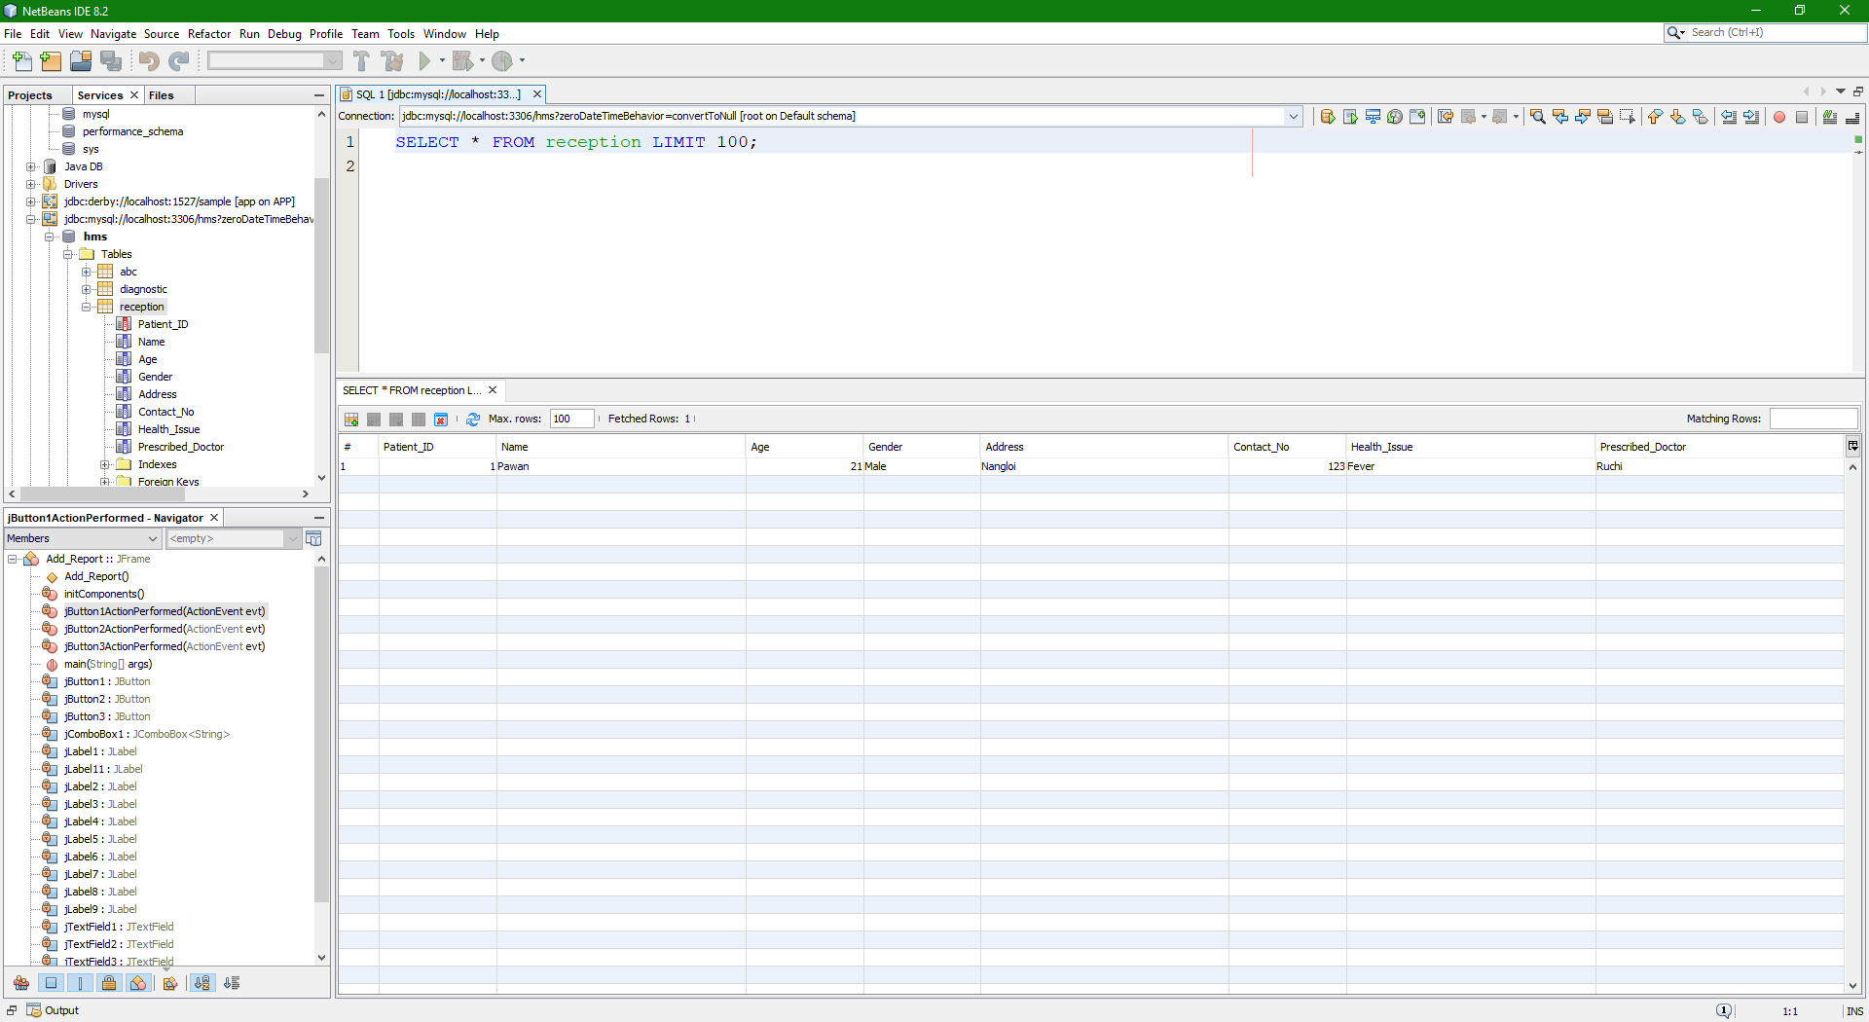
CHAPTER 4: CONCLUSION AND FUTURE SCOPE

4.1 Conclusion
4.2 Limitation of Existing System
4.3 Future Scope
4.4 Bibliography/References

4.1 Conclusion
The project "Delhi Central Hospital” is completed, satisfying the specified design specifications. The system can add, view, search, and delete the patients records rapidly. The software is developed through modular approach. All modules within the system are tested with valid/invalid data and everything works accordingly. Records at the backend are getting stored in the form of tables, which are easy to interpret. With the help of SQL constraints, there is accuracy and reliability of the data in the database. The software has the ability to maintain the uniqueness of the patient’s data, which will result in less ambiguity. Thus, the system has fulfilled all the objectives identified and is in a position to switch the present system. The constraints are met and overcome successfully. The system is intended as if it absolutely was decided within the design phase. This software incorporates a user-friendly screen that permits the user to use without any inconvenience.

4.2 Limitation of Existing System
- It is not a web-based application.
- There is no billing section.
- The software will not provide any information regarding room allotment.

4.3 Future Scope for Modification
This application can be easily executed under various situations. We can add new features as Reminders, put in Record, a billing section and room allotment information. Reusability is feasible as and when require during this application. There is flexibility in all the modules.

4.4 SOFTWARE SCOPE:
This project was developed to fulfil trainers’ requirement. However, there are lots of scope to improve the performance of the record system in the area of record and query processing time.
Therefore, there are many things for future enhancement of this project. The enhancements, which can be done in the future, are as follows:
- Web Based interface for system administrator to modify database.
- In the area of data security and system security.
- Provide more tips and help wherever required.

4.4 Bibliography/References
BOOKS:
- Software Engineering by Roger S. Pressman
- Java-the-complete-reference-8th-edition

ONLINE REFERENCE:
1. www.geeksforgeeks.com
2. https://www.javatpoint.com/java-tutorial
3. www.tutorialspoint.com

